Research Title …………

29 mm
(from the edge of the page)

TH SarabunPSK 16 point

…………………………………………………………………

Pongchanun Luangpaiboon¹ Kannapa Amratchakul² and Pronpimol Chaiwuttisak^{3,*}

¹Department of Industrial Engineering, Faculty of Engineering,

Thammasat University (Rangsit Center), Pathum Thani, 12120

²Faculty of Applied Statistics, National Institute of Development Administration, Bangkok, 10240

³Department of Statistics, School of Science,

King Mongkut’s Institute of Technology Ladkrabang, Bangkok, 10520

E-mail: ¹lpongch@engr.tu.ac.th, ²kamaruchkul@as.nida.ac.th, ³pornpimol.ch@kmitl.ac.th

TH SarabunPSK 12 point

Abstract

This abstract is intended for an oral presentation at the 2026 National Conference on Operations Research, and the article's format must be strictly adhered to. Any abstracts that are incorrectly formatted will be returned and not considered this time. The abstract should be presented in both Thai and English, each containing only one paragraph, with a maximum length of 25 lines.

Keywords: manuscript format, font size, font style
a 1-line space

21 mm
(from the edge)

81 mm
21 mm
(from the edge)
6 mm
81 mm
1. Introduction
The articles should follow the sections in the following order: Research title in Thai and English, author's name, institution, institutional address in detail, and abstract in Thai. The manuscript should be divided into an introduction, main contents, summary, acknowledgments (if any), references, and appendix (if any).
a 1-line space
2. Writing and Typing Instructions
2.1 General Recommendations
This proposed manuscript must be written in Thai and should not exceed 12 pages in size A4 paper.
It should be in two columns, according to this manuscript, which has a specific size of columns without line breaks.
When starting a new heading (section), please enter one line space. The entire column must be typed before starting a new column or page, and avoid leaving blank spaces.
To organize sections in the manuscript, please number them with the first section as "1" and use decimal numbers for subsections, such as "2.1," without line gaps between subsections.
2.2 Font Size and Spacing
For Thai articles, the "TH SarabunPSK" font is used with the following specifications:
- Research Title: Use 16-point bold font.
- Author Name: Use 12-point bold font.
- Name of Institution: Use 12-point bold font. If multiple authors are from the same organization, list them with the same institution number, e.g.,

The first author¹ and The second author²
^{1, 2}Institution of the first and second authors,
which are the same.

- Subheadings (subsections): Use 14-point bold font.
- Abstract and body paragraphs: Use 12-point font.
- Equations/Inequalities: Use 14-point or 10-point in Times New Roman letters.
- Maintain a vertical line spacing of 16 points by choosing "Exactly 16 point".
- Align text to the left and the right by choosing "Justify" on each line.
2.3 Title, Author Name, Author's Institution, and Headings
Type the title in the center of the page, starting with the Thai title and then the English title on a new line.
The author's name should be placed below the title, centered in a single column without specifying titles or academic status.
The author's institution should be placed under the author's name in the center of the page of a single column that specifies the institution's address in detail in the following order: "Department/School (if any), Faculty, University, Province, Postal Code, and E-mail of all authors are included under the institution's address sorted by author's name."
Subheadings should align along the left edge.
2.4 Image Preparation
Images should not be wider than 81 millimeters (mm) to fit within one column, but if necessary to preserve image details, they can extend to the full page width (168 mm).
Ensure that all text within images is large enough and readable with no smaller than those in the main content.
Each image should have a number and its caption placed under the image with the combined number and caption no longer than 2 lines.
Avoid using the word "show" in captions; for example, "Fig. 1 Show relationship…". This could appropriately be written as "Fig. 1 Relationship between…".
Ensure that line drawings must be in black, and images are sharp in black-white tone. Color images are acceptable if essential. Images should only include necessary details, such as an oscilloscope image of the wave that appears only the monitor. Leave one line above the image and one line below the image caption.
2.5 Writing Equations/Inequalities
Equations and inequalities must be numbered within parentheses and correctly aligned with the right edge of the column. For example:
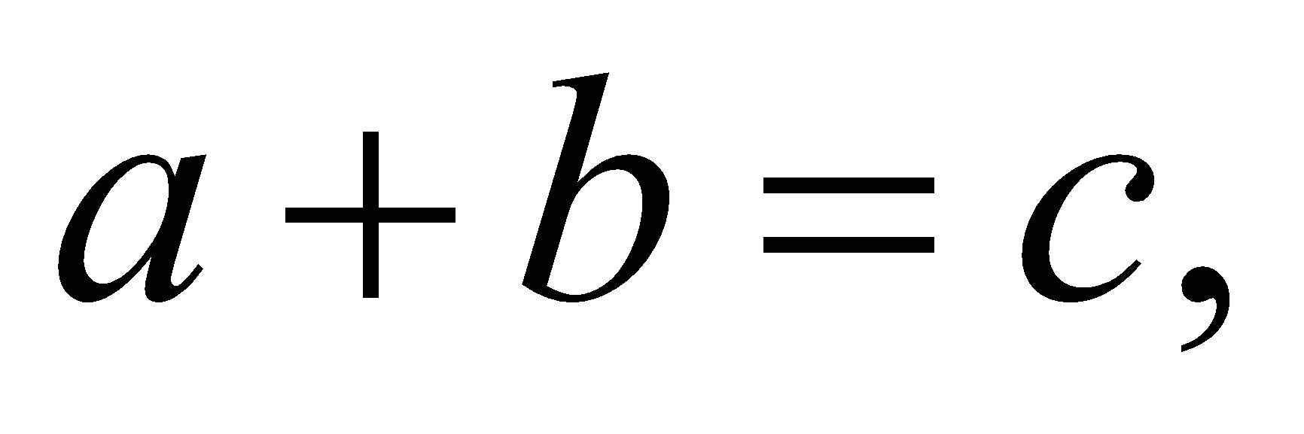 (1)
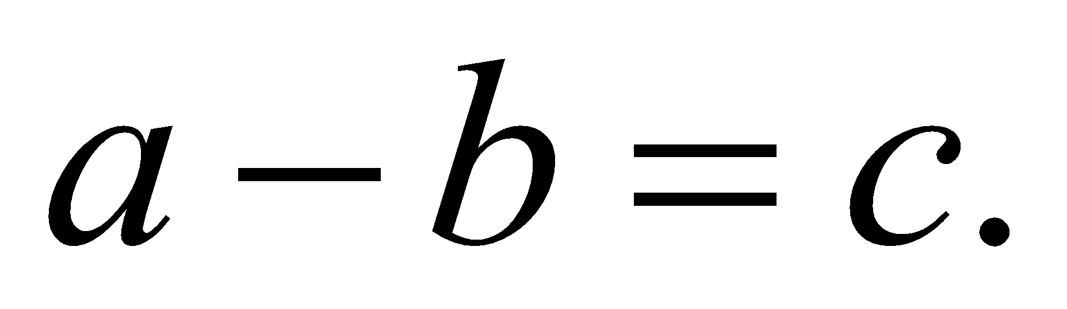 (2)
Start writing the description from this line.
2.6 Table Preparation
Text in tables should not have smaller than those in the main content. The grid lines of the tables should be clearly drawn.
Every table should have a number and caption above it with its number and caption combined n no more than 2 lines. Avoid using the word "show" in table captions as mentioned in the image captions; use it as "Table 1 Relationship between…". Leave one line above the table caption and one line below the table.
2.7 Citation and References
References in the article should be enclosed in brackets, e.g., [1]. Reference numbers should be sorted in ascending order. For consecutive reference numbers, use the format [1-5] and follow the IEEE standard format for references. The list of references should have the title of the cited article labeled and aligned, as shown in the references section below. All lists have equal left-margin spacing.

3. Article in English
For the English version of the article, please refer to the instructions provided on how to format and prepare it.
a 1-line space
4. Conclusion
Authors are kindly requested to carefully review their articles and take sufficient time before submitting them for consideration by the committee. This will be high-quality articles that increase opportunities for accepting your submission.

Acknowledgments
We extend our gratitude to all authors for their cooperation in adhering to these strict article writing guidelines.

References

Wutiphol Sintunawarat, Kachaporn Tangsamphan, Jirarak Wongthitaporn, and Pattiya Atthakarnpong, " The Application of Queuing Theory to Minimize the Total Cost for Employees Scheduling Problems: A Case Study of 7-Eleven at Inter Zone, Thammasat University Rangsit Center", Proceedings of Operations Research Network Conference 2019, pp. 307-314, 2019.

Pandhita Norasretpanya, Kasita jittasamroeng, and Wutiphol Sintunavarat, "Efficiency Analysis of Hydroelectric Power Plant Establishment for Medium Reservoirs: A Case Study of Lampang Province", Thai Journal of Operations Research, Vol. 10, No. 1, pp. 128-139, 2022.

………………………………………………………………………………………………………………………………………………………………………………………………………………………………………………………………

Name of the first author (No title required)

Author's Biography All authors must write a title, a brief biography and research interests, and scan the original photograph only.
Scan a photo
2 cm x 2 cm

Name of the second author (No title required)

Author's Biography All authors must write a title, a brief biography and research interests, and scan the original photograph only.
Scan a photo
2 cm x 2 cm

Name of the third author (No title required)

Author's Biography All authors must write a title, a brief biography and research interests, and scan the original photograph only.
Scan a photo
2 cm x 2 cm

